BIOU9PC: Population and Community Ecology

Lab Practical 12: Spatially-explicit predator prey models

1 December 2016

**Objective**

The purpose of this practical is for you to interact with two versions of a realistic predator-prey models. In so doing, you will

1. explore the linkages between ecological processes and their representations in models
2. explore how explicitly accounting for space affects the outcome of models
3. explore ways to use models to predict the outcome of predator-prey interactions
4. design and execute a modeling study of predator-prey dynamics.

**Introduction**

***Space in ecological interactions***

Until now, the models we have used in the practical sessions of this module have considered space *implicitly*. In fact, in all previous practicals, we modeled the dynamics of populations, rather than individuals. In them, we assumed that the interacting populations were well mixed. For example, in the predation practical, we assumed that all predators had access to all prey at all times.

In reality, however, populations have spatial structure, because individuals are located at specific locations in space. This has several effects on their ecology. First, an individual’s spatial location restricts the set of individuals that it can interact with to be those in its local neighborhood. Second, space (together with the sensory organs of the organism in question) affects the detectability of predators and prey. Third, heterogeneity in the spatial distribution of resource availability, refuges, mates and abiotic conditions (etc) can strongly influence ecological processes. Finally, the viscosity of the environment, together with the dispersal abilities of the organism, affects how quickly they can move through space. All of these factors influence ecological interactions among organisms. A final consideration is the dimensionality of space. For terrestrial organisms, the world is (to a first approximation) flat, whereas for aquatic, marine or airborne organisms it is three-dimensional. In the sky or the water, a predator may be above you.

**Modeling platforms**

Today you will use two modeling platforms, R and NetLogo, in which the same spatially explicit two-species model has been developed. The primary motivation behind using NetLogo as well as R is to provide an alternative way for you to interact with a relatively detailed model. This feeds into the secondary motivation, which is to evaluate the educational potential of R and NetLogo. This will help improve teaching provision in future years. NetLogo is a multi-agent programmable modeling environment used by tens of thousands of students, teachers and researchers worldwide. Models are written in the NetLogo language and NetLogo provides a graphical user interface for model users.

**Description of model**

ARENA: You will simulate predator-prey dynamics in a homogeneous, two-dimensional closed habitat. The habitat is rectangular, with dimensions you specify[1]. The model is spatially explicit, with each individual having a set location. In R, space is continuous and individuals occupy X-Y coordinates. In NetLogo, individuals occupy grid cells, but the grid is so fine that space is “effectively continuous”. In both R and NetLogo, by joining the top and bottom edges of the arena, or the left and right edges, we can create either a vertical (or horizontal) cylinder. By joining both the top/bottom and the left/right edges, we create a torus (a donut). These manipulations make the spatial area of simulation endless.

TIME: Time is discrete, with a small step size.

MOVEMENT: Prey move throughout the habitat at a speed you determine (Nspeed). They move in randomly-chosen directions, unless there is a predator within a ‘dodge_radius’, in which case they move away from the nearest predator (with a certain degree of error). Predators, likewise, move at a speed you determine (Pspeed). Again, they move randomly unless they are within a ‘search_radius’ of prey, in which case they move towards the nearest prey (again, with a certain degree of error). When a prey is located within a certain ‘catch_dist’ of a predator it is considered to be caught and eaten by that predator. If several predators catch a prey simultaneously, they share it. We assume that all prey contain the same level of resources, as far as the predator is concerned.

GROWTH: Prey grow by acquiring resources from the environment. There is density dependent competition among prey, however. We assess how many other prey are present in the neighborhood around each individual. Elevated local density reduces the resource gain for each affected prey. This effect is modulated by the parameter ‘dd’ (density dependence). When dd is high, the effect of local crowding is particularly severe. Predators, on the other hand, grow by consuming prey.

REPRODUCTION: Prey and predators must obtain a threshold level of resources from the environment in order to reproduce. Reproduction is by asexual budding: each new individual is generated at the same location as the parent, with a minimal level of resources. The threshold levels of resources necessary for reproduction by prey and predators (‘Nb’ and ‘Pb’) are set by the user.

DEATH: Mortality for the prey occurs only when they are consumed by the predator. Predators face a user-defined per-capita probability of death (d) in every time-step.

INITIAL CONDITIONS: The indicates how many predators and prey are initially present in the habitat. Individuals are located randomly, with a random initial energy level.

**Model outputs**

Unlike the Lotka-Volterra models, we cannot algebraically evaluate the stability of this predator-prey system, because the models are stochastic. We evaluate stability, therefore, as the persistence of the two species to the ‘max.time’ (a variable that you can adjust). Furthermore, we can obtain from the model the mean population size of the prey and predators, as well as their ranges, which gives an indication of the amplitude of variation in population sizes. Greater oscillations, and oscillations that intensify through time, are indicators of instability, whereas small and damped oscillations indicate relative stability.

In addition to population dynamics, we can observe the spatial patterning of predators and prey in the arena – are they all spread out? Do predators hunt as a group? Do prey disperse from one another, and from predators?

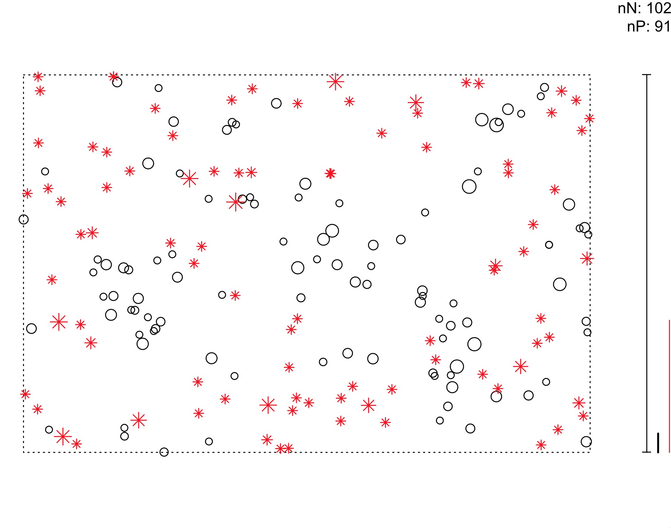**Figure 1. Example graphical output from the spatially explicit predator-prey models**. *Top*: NetLogo, *Bottom*: R. In NetLogo, prey are shown as white sheep and predators as black wolves, whereas in R, prey are black circles and predators are red stars. In both, their size indicates their current level of resources. In R, the heavy black bar on the right indicates the ‘catch distance’ of the predator. Any prey within this distance of a predator dies. The thin red line indicates the dodge radius of the prey. If there are predators within this distance, prey will try to avoid them. The tall thin bar at the bottom right indicates the progress of the simulation up to the maximum number of time-steps specified by the user. This simulation run just ended, with 102 prey and 91 predators alive at the end. Similar information is provided in NetLogo’s graphical user interface.

**Plan of the day**

In the first hour, one half of the class will use the NetLogo model while the other half uses R. In the second hour, they will switch, so that every student uses both modeling platforms. Before and after each hour, all students will complete brief questionnaires about their knowledge level and experience using each program.

In the third hour, use the modeling platform of your choice. There are many manipulations that you can explore, some of which are listed below. Consider what parameters of the model you will manipulate, and what response variables you will measure to evaluate your hypotheses. Consider how you will replicate your explorations to obtain confidence in your results.

**Manipulations**

You can use this system to investigate a wide variety of ecological scenarios. For example, please test the hypotheses that…

* …the probability of prey survival decreases as their speed decreases and the predator speed increases.
* … increasing the predator’s search radius decreases the probability of stable coexistence, whereas decreasing the search radius increases it. Changes in the dodge radius would have the contrary effect.
* … changing the resources needed for reproduction for predator and prey would affect their population sizes and stability.

In this practical, I encourage you to work with your neighbors. Your report, however, must be written in your own words. Write your reports *independently*. Turn in this assignment using Turnitin by **Monday December 8th at noon**. Indicate your identity with your student number, and only your student number.

Many additional manipulations are possible in this model! For example, reproduction could generate multiple young, distant from adults. Prey could be made immobile, to mimic plants or sessile animals. Consult with the instructor for help in the implementation of further complications.

You can also explore the dynamics of a wide variety of predator prey interactions…

* You could create a plant-herbivore system by decreasing the speed of the prey to 0.
* You could create a host-parasite system by causing each prey consumed to generate a relatively large number of new predators.
* You could create competition by causing the interaction coefficients for both species to be (slightly) negative.

1. In the R model, you can make the arena circular.